
LinkedIn

Product Dissection for LinkedIn
Company Overview:
LinkedIn Corporation is the world’s largest professional networking platform, designed to connect professionals across industries, geographies, and roles. Founded in 2002 by Reid Hoffman and team, and officially launched in 2003, LinkedIn enables individuals to build professional profiles, showcase skills, share content, and grow their careers. Headquartered in Sunnyvale, California, USA, LinkedIn operates as a subsidiary of Microsoft Corporation (acquired in 2016 for $26.2 billion).

Product Dissection & Real-World Problems Solved by LinkedIn:
LinkedIn is more than just a job portal; it’s a full-fledged professional ecosystem. At its core, the platform allows users to build detailed professional profiles that act like a dynamic résumé. Features such as LinkedIn Jobs, Learning, Sales Navigator, and Marketing Solutions extend its use beyond job searching, supporting recruitment, upskilling, networking, and business growth. The design emphasizes user-friendly navigation, personalized feeds, and powerful search algorithms that make it easier for professionals to connect, share insights, and grow their careers globally.
LinkedIn solves multiple real-world challenges faced by professionals and organizations. For job seekers, it bridges the gap between talent and opportunity, allowing them to discover openings across industries and geographies. For companies, it offers an efficient way to source, vet, and recruit candidates through targeted filters and employer branding. Moreover, it helps businesses generate leads, expand networks, and build thought leadership—problems that traditional job boards or offline networking could not effectively tackle.
In essence, LinkedIn has transformed how professionals showcase their identity, connect with others, and find career opportunities. Its ability to combine recruitment, learning, and networking into a single platform has made it indispensable in today’s digital-first workplace. However, like any product, it is not without limitations—such as algorithmic biases, rising competition, and premium feature costs. Despite these challenges, LinkedIn remains a powerful tool for professional growth, continuously evolving to solve real-world problems at scale.
Case Study: Real-World Problems and LinkedIn's Innovative Solutions
LinkedIn has redefined the professional landscape by addressing real-world challenges such as limited networking, inefficient hiring, and lack of continuous learning. Through innovative solutions like personalized feeds, skill-based learning, targeted recruitment tools, and business growth platforms, it has created a holistic ecosystem that empowers individuals to showcase their identity, expand connections, upskill, and explore opportunities globally. In essence, LinkedIn goes beyond being a job portal—it is a dynamic hub for professional growth, collaboration, and innovation.

Problem 1: Disconnect in Professional Relationships
Real-World Challenge: As our lives become increasingly digital, the lack of genuine connections in online interactions has become a prevalent concern. Users often struggle to convey emotions and experiences effectively through text-based communication alone, leading to a disconnect in professional relationships.

LinkedIn's Solution:
LinkedIn recognized the need for authentic expression in digital interactions. By allowing users to share photos and videos alongside captions, locations, and hashtags, the platform creates a visually rich environment where users can enhance their network as well as share their lives more vividly. LinkedIn enabling users to connect on a deeper level. Through this approach, LinkedIn effectively tackles the problem of disconnection, nurturing meaningful relationships and promoting genuine interactions.

Problem 2: Gap Between Recruiters and Job Seekers
Real-World Challenge: While there are numerous platforms available for job seekers, many struggle with issues of authenticity and credibility. Fake postings, lack of verified employer details, and intermediaries often create confusion and mistrust, making it difficult for candidates to connect with genuine opportunities.

LinkedIn’s Solution:
LinkedIn bridges this gap by offering a trusted and transparent platform where recruiters and job seekers can interact directly. Verified company profiles, official job postings, and advanced filters ensure authenticity and reliability. Recruiters can easily share openings, and candidates can apply seamlessly—without relying on third-party intermediaries. This not only builds trust but also creates a smoother, faster, and more efficient hiring process.

Problem 3: Lack of Personal Branding Opportunities for Professionals

Real-World Challenge: Traditionally, professionals only had static résumés or CVs, which listed skills and experiences but didn’t allow them to showcase expertise, share knowledge, or build credibility in real time. This made it hard to stand out from the crowd, especially in competitive industries.

LinkedIn’s Solution:
LinkedIn allows professionals to build a strong online identity through posts, articles, and profile highlights. Unlike traditional resumes or job portals, it gives people a voice to showcase expertise, share insights, and establish themselves as thought leaders in their industries.

Problem 4: From Skill gap to Skills Growth

Real- World Challenge: Limited access to relevant, high-quality upskilling opportunities
In the traditional setup, professionals often struggled to find personalized learning resources that matched their career goals. Access to courses from industry leaders or insights into global trends was restricted to universities, seminars, or expensive programs—making continuous learning harder.

LinkedIn’s Solution:
Through LinkedIn Learning and curated industry content, users gain access to on-demand courses, expert-led sessions, and skill recommendations tailored to their career path. This not only helps professionals upgrade their skills at their own pace but also stay aligned with evolving industry trends, making learning flexible, credible, and globally accessible.

Conclusion:
LinkedIn has successfully transformed itself from a simple networking site into a comprehensive professional ecosystem that addresses some of the most pressing challenges in today’s career landscape. By solving problems around authentic connections, transparent hiring, personal branding, and accessible upskilling, LinkedIn empowers professionals to not only showcase who they are but also grow into who they aspire to be. In a world where professional relevance is constantly evolving, LinkedIn stands out as a trusted platform in creating meaningful careers and building a globally connected workforce.

Top Features of LinkedIn:

1. Profile & Personal Branding
Your LinkedIn profile works like a digital resume but more dynamic. You can highlight skills, work experience, certifications, and achievements. Unlike a traditional CV, it also shows endorsements, recommendations, and posts that build your personal brand.

2. Networking & Connections
LinkedIn helps you connect with colleagues, industry leaders, recruiters, and professionals worldwide. You can send invitations, follow updates, and join groups. This builds meaningful relationships that can open doors to new opportunities.

3. Job Search & Recruitment Tools
LinkedIn’s job portal is trusted because of verified company postings and advanced filters. Job seekers can apply directly, while recruiters can target the right talent. It simplifies and speeds up the hiring process for both sides.

4. LinkedIn Learning
This feature offers thousands of expert-led courses across different industries. Learning is flexible—you can upskill anytime at your own pace. It also gives skill recommendations based on your career goals and profile.

5. Content Sharing & Thought Leadership
Users can share posts, articles, and videos to showcase expertise and insights. This helps professionals engage with their network and build credibility. Over time, it positions them as thought leaders in their field.

6. Company Pages & Business Growth
Organizations can create LinkedIn pages to showcase culture, updates, and job opportunities. This strengthens employer branding and attracts top talent. Businesses can also use the platform to generate leads and build partnerships.

Schema Description:
The schema for LinkedIn involves multiple entities that represent different aspects of the platform. These entities include Users, Posts, Comments, Likes, Share/Repost, Connection, Message, Job Posting, Job Application and more. Each entity has specific attributes that describe its properties and relationships with other entities.

User Entity:
Users are at the core of LinkedIn. The user entity contains information about each user:
- User_ID (Primary Key): A unique identifier for each user.
- Name: The chosen username for the user's account.
- Headline: A brief description of user.
- Email: The user's email address for account-related communication.
- Bio: A brief description that users can use to express themselves.
- Registration_Date: The date when the user joined LinkedIn.

Post Entity:

Posts capture the visual content shared on the platform:

- PostID (Primary Key): A unique identifier for each post.
- User_ID (Foreign Key referencing User Entity): The user who created the post.
- Caption: Text accompanying the post, providing context.
- Content_Type: Text, Image, Video, Article
- Content_URL: The URL of the image or video content.
- Location: The tagged location associated with the post.
- Post_Date: The timestamp when the post was created.

Comment Entity:

Comments enable users to engage in conversations around posts:

- Comment_ID (Primary Key): A unique identifier for each comment.
- PostID (Foreign Key referencing Post Entity): The post being commented on.
- User_ID (Foreign Key referencing User Entity): The user who posted the comment.
- Text: The text of the comment.
- Comment_Date: The date when the comment was posted.
Like Entity:

Likes represent user appreciation for posts:

- Like_ID (Primary Key): A unique identifier for each like.
- PostID (Foreign Key referencing Post Entity): The post being liked.
- User_ID (Foreign Key referencing User Entity): The user who liked the post.
- Like_Date: The date when the like was registered.

Share/Repost:
Tracks who share/repost content or any other post:
- Share_ID (Primary key): A unique identifier for each share.
- PostID (Foreign Key referencing Post Entity): Unique identifier for the post shares/repost
- User_ID (Foreign Key referencing User Entity): The user who share/repost.
- Time: Timestamp of content shared/repost
- With_Text: Optional comment when sharing

Follow
Tracks follow_ID along with followers and following ID.

- Follow_ID (Primary key): A unique identifier for each follow
- Follower_ID (FK referencing User.User_ID): References the user who is following (FK → User_ID).
- Following_ID (FK referencing User.User_ID): References the user who is being followed (FK → User_ID).
- Time: Timestamp when the follow activity happened.

Message
Stores private communication:

- Message_ID (Primary key): A unique identifier for each message.
- Sender_ID (Foreign key referencing User.User_ID): References the user who is sending (FK → User_ID).
- Receiver_ID (Foreign key referencing User.User_ID): References the user who is receiving the message (FK → User_ID).
- Text : Whatever message communicated between sender and receiver.
- Attachments: Any file, image, document attached with message.
- Time: Timestamp of activity happened.
Connection

Represents the mutual professional connection (different from "follow").

- Connection_ID (Primary key): A unique identifier assigned to each user connection.
- User_ID_1(Foreign key referencing User.User_ID): References the user who is sending the connection (FK → User_ID).
- User_ID_2 (Foreign key referencing User.User_ID): References the user who is receiving the connection (FK → User_ID).
- Status: Pending, Accepted, Removed
- Time: Timestamp when the connection was created.

Job Posting

Jobs posted by companies/recruiters.

- Job_ID (Primary key): A unique identifier assigned to each job post.
- Recruiter_ID (Foreign key referencing User.User_ID): References the user who is recruiting (FK → User_ID).
- Title: Title of job
- Description: Description of job
- Reqirements: Eligibility criteria and other requirements
- Location: Address of the company and interview location
- Post_Date: Timestamp of posted job offer.

Job Application

Links users with jobs they apply for.

- Application_ID (Primary key): A unique identifier assigned to each application.
- Job_ID (Foreign key referencing Job posting entity): Rererences the Job_ID from job posting entity.
- User_ID (Foreign key referencing User.User_ID): References the user who is applying (FK → User_ID).
- Resume: Resume, CV, Cover letter
- Applied_Date: Timestamp of job applied activity happened.

Relationships are:
- Users post Posts – Each user can post multiple posts.
- Users comment on Posts – Users can comment on multiple posts, and each post can have multiple comments.
- Users like Posts – Users can like multiple posts, and each post can have multiple likes.
- Users sends connection – Users can send multiple connection requests, and each users can receive multiple connection requests.
- Users applied for job – Users can apply for multiple of jobs, and each users can recruit multiple of users.
- Users message another user – Users can send multiple messages to other users, and each users can receive multiple messages from different users.
- Users follow another users – Users can follow another users, and each users can have multiple of followings.
ER Diagram:
Let's construct an ER diagram that vividly portrays the relationships and attributes of the entities within the LinkedIn schema. This ER diagram will serve as a visual representation, shedding light on the pivotal components of LinkedIn's data model. By employing this diagram, you'll gain a clearer grasp of the intricate interactions and connections that define the platform's dynamics.
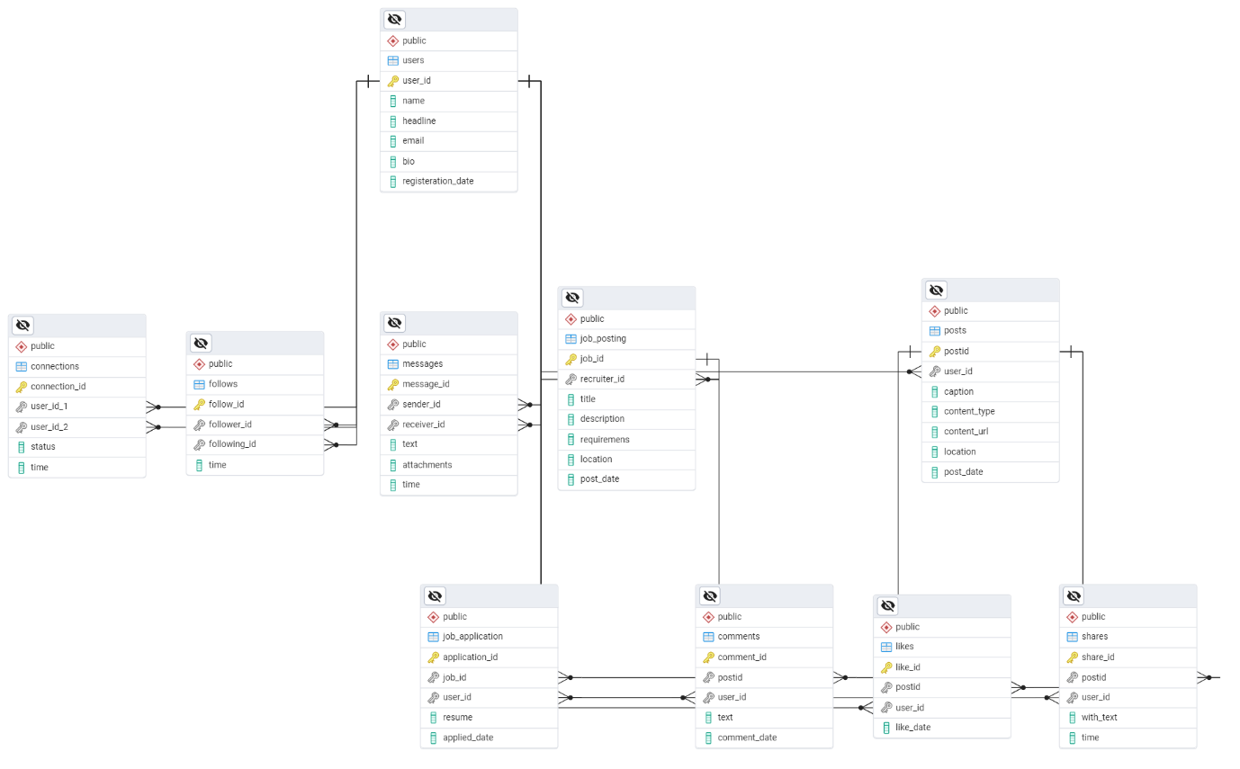

Conclusion

In this case study, we delved into the design of LinkedIn’s schema and Entity-Relationship diagram. LinkedIn has revolutionised the way people build their professional carrier, recruit from all over the world, share and engage with visual content, fostering connections and creative expression. The platform's intricate data model, consisting of entities like users, posts, comments, likes, job posting, connections, and associations, forms the foundation for its seamless functionality. By understanding this schema, we gain insight into how LinkedIn effectively manages the complexities of user interactions, hiring, content sharing and many more that contributes to its widespread popularity and continued growth in the world of professional networking.

